LECT. 1, 2 :

Intro. to The Subject, Scope, Syllabus Contents ,

Students, Faculty Introduction

Assessment Pattern,

Attendance , Submission Discipline

Engineering Field ,

Intro. to Products, Product Design and development, Innovation, Invention, etc. (Use the PPT )

https://www.youtube.com/watch?v=wYeXCeBZhjE

[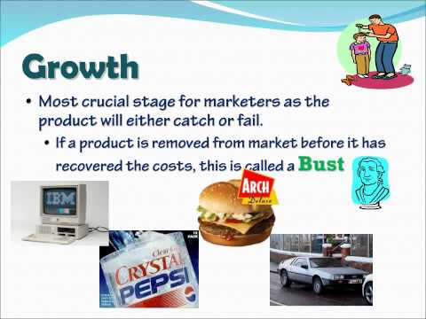](https://www.youtube.com/embed/wYeXCeBZhjE?feature=oembed)

<https://www.youtube.com/watch?v=o3CizbLkV8Q>[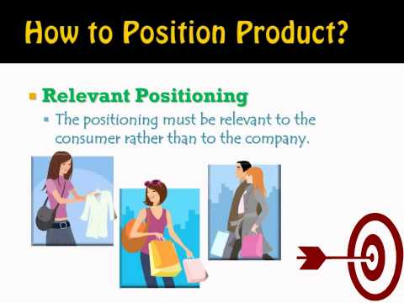](https://www.youtube.com/embed/o3CizbLkV8Q?feature=oembed)

<https://www.youtube.com/watch?v=M5-sreePyko>

[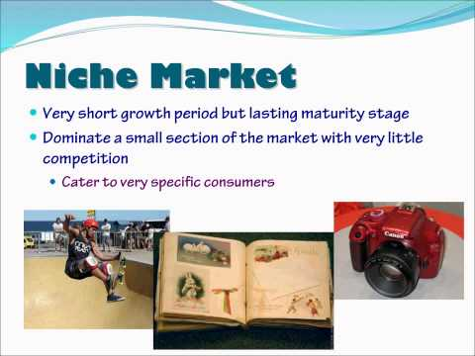](https://www.youtube.com/embed/M5-sreePyko?feature=oembed)

<https://www.youtube.com/watch?v=gWS5GHltYiQ>

[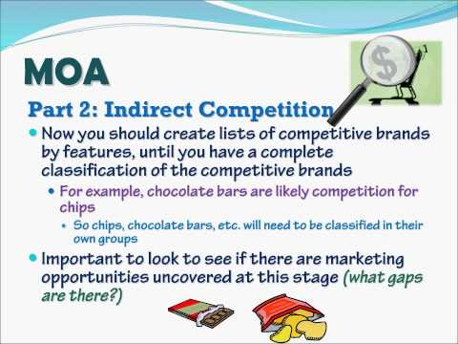](https://www.youtube.com/embed/gWS5GHltYiQ?feature=oembed)

https://www.youtube.com/watch?v=eiNZyKKTOek

[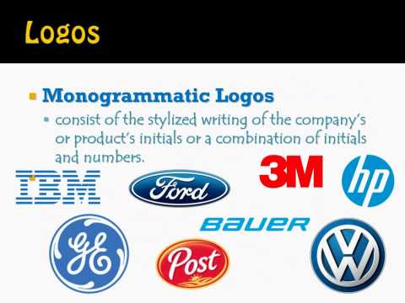](https://www.youtube.com/embed/eiNZyKKTOek?feature=oembed)

https://www.youtube.com/watch?v=3__SyyFTRmc

[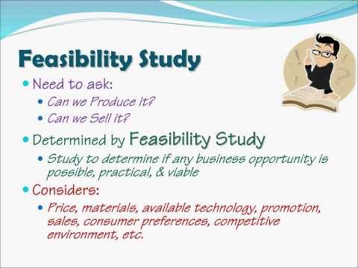](https://www.youtube.com/embed/3__SyyFTRmc?feature=oembed)

https://www.youtube.com/watch?v=ioTv9m-M6QI[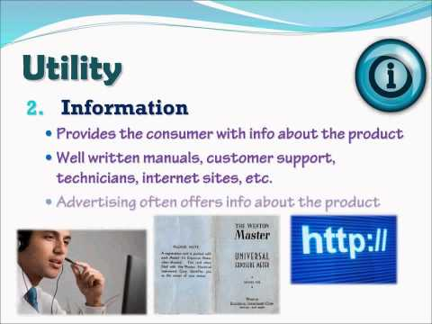](https://www.youtube.com/embed/ioTv9m-M6QI?feature=oembed)

https://www.youtube.com/watch?v=KWy4UgbzCBU

[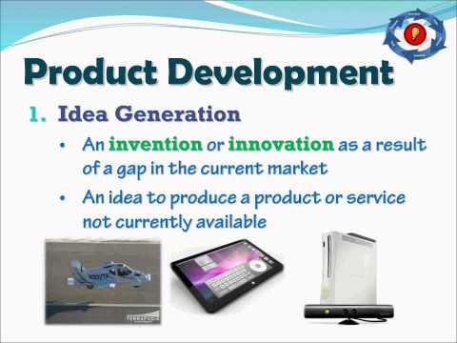](https://www.youtube.com/embed/KWy4UgbzCBU?feature=oembed)

https://www.youtube.com/watch?v=osLpjXBXBS0

[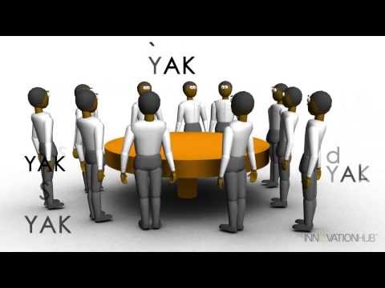](https://www.youtube.com/embed/osLpjXBXBS0?feature=oembed)

https://www.youtube.com/watch?v=pQgxiQAMTTo[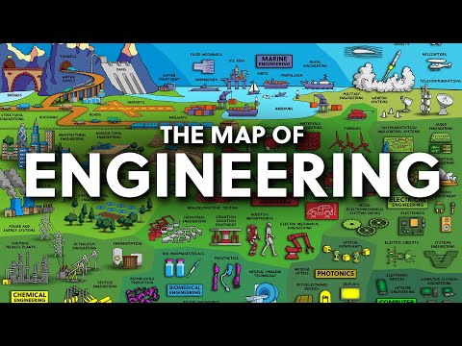](https://www.youtube.com/embed/pQgxiQAMTTo?feature=oembed)